Software Requirements and Design Document
For
Chupi — Party Games Application
Version 1.1
Authors:
Teena Singh
Chiara Savoretti
Ramon Ortega
Francisco De La Esp.
Samuel Marcano

Overview
Chupi is a mobile-friendly party games application designed to bring players together through a collection of popular social drinking games. The application serves as a digital host for game nights, eliminating the need for physical cards, boards, or other accessories typically required for party games.
In its current prototype phase (console-based), Chupi offers seven distinct game modes: Truth or Drink, Who’s Most Likely To, Dare Roulette, Imposter, Waterfall, Screw the Dealer, and Party Mode. The system supports 2 to 10 players per session and manages player turns, game rules, and game flow through a centralized menu-driven interface. The final product is intended to be deployed as a responsive mobile website accessible from any modern web browser, requiring no installation.

Functional Requirements
ID | Description | Priority
FR-01 | The system shall allow the user to enter the number of players (between 2 and 10) at the start of a session. | High
FR-02 | The system shall prompt each player to enter a unique, non-empty display name. | High
FR-03 | The system shall display a main menu listing all available game modes: Truth or Drink, Who’s Most Likely To, Dare Roulette, Imposter, Waterfall, Screw the Dealer, and Party Mode. | High
FR-04 | The system shall allow the user to select a game mode from the main menu by entering the corresponding number. | High
FR-05 | The system shall launch the selected game with the registered players and manage the game session until completion. | High
FR-06 | The system shall track which player’s turn it is during turn-based games and cycle through players in order. | High
FR-07 | The system shall display the rules of each game before gameplay begins. | Medium
FR-08 | The system shall allow users to return to the main menu after a game ends and select a new game or quit. | High
FR-09 | In Truth or Drink, the system shall present random personal questions to the current player each turn. | Medium
FR-10 | In Who’s Most Likely To, the system shall present a prompt and allow all players to vote on who best fits the prompt. | Medium
FR-11 | In Dare Roulette, the system shall randomly assign dares of escalating difficulty to players. | Medium
FR-12 | In Imposter, the system shall secretly assign one player the imposter role and give all other players the same word. | Medium
FR-13 | In Waterfall, the system shall simulate drawing cards and display the corresponding rule for each card drawn. | Medium
FR-14 | In Party Mode, the system shall randomly select and alternate between different game types during a single session. | Low
FR-15 | The system shall gracefully handle invalid user input (non-numeric entries, out-of-range values) and re-prompt the user. | High
FR-16 | The system shall allow users to quit the application at any time by entering ‘Q’ from the main menu. | High
FR-17 | In Screw the Dealer, the system shall designate one player as the dealer and cycle other players as guessers. The dealer draws a hidden card and the guesser has two attempts to guess its value. A correct first guess results in the dealer drinking 2; a correct second guess results in the dealer drinking 1. An incorrect second guess results in the guesser drinking the numeric difference between their guess and the actual card value. After three consecutive rounds where the guesser fails on the first attempt, the dealer role passes to the next player. | Medium

Non-functional Requirements
ID | Description | Priority
NFR-01 | The application shall respond to user input within 1 second under normal operating conditions. | High
NFR-02 | The system shall be usable by a first-time user without external documentation or training. | High
NFR-03 | The codebase shall follow an object-oriented architecture with clear separation of concerns (core logic, game modules, and main entry point). | High
NFR-04 | Each game module shall extend a common base class (GameBase) to ensure consistent interfaces and facilitate adding new games. | Medium
NFR-05 | The system shall run on any platform that supports Python 3.8 or higher without requiring additional native dependencies. | High
NFR-06 | The final mobile website version shall render correctly on screens from 320px to 1024px wide (responsive design). | Medium
NFR-07 | The system shall handle unexpected errors gracefully, displaying a user-friendly message rather than a stack trace. | Medium
NFR-08 | The source code shall include docstrings and type hints for all public classes and functions. | Low
NFR-09 | The system shall support future extension with new game types without modification to the core framework or main loop. | Medium
NFR-10 | The application shall maintain player session data in memory for the duration of the session without requiring a database. | Medium

Use Case Diagram
The use case diagram below represents the primary interactions between the Player actor and the Chupi system. The Player can register players, select a game mode, play any of the seven available games, and quit the application. Party Mode includes behavior from all other game types.
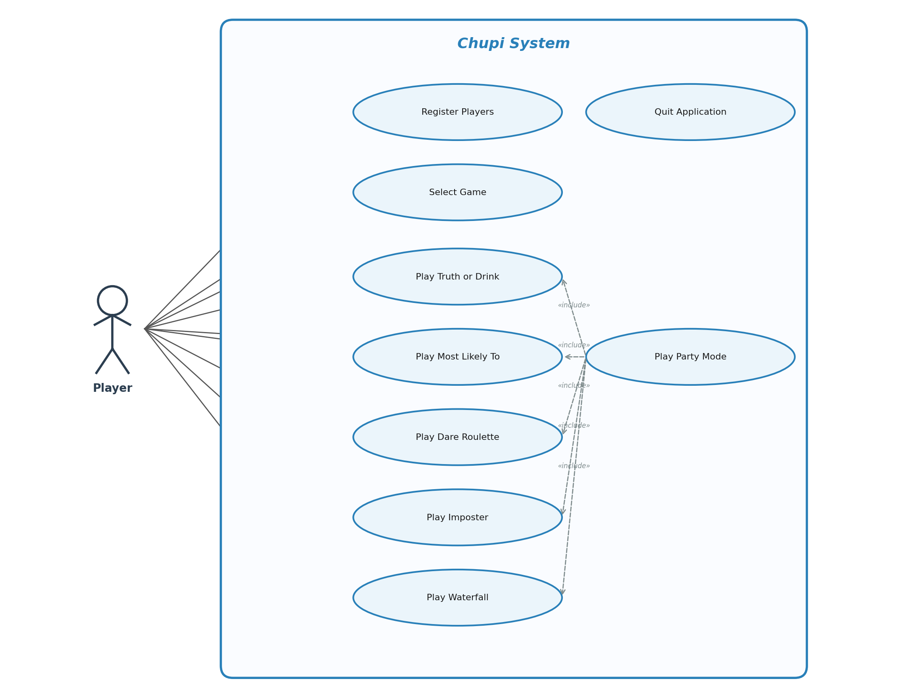
Figure 1: Use Case Diagram for Chupi

Use Case Descriptions
Use Case | UC-01: Register Players
Actor(s) | Player (Primary)
Precondition | The application has been launched.
Main Flow | 1. The system prompts for the number of players. 2. The user enters a number between 2 and 10. 3. For each player, the system prompts for a display name. 4. The user enters a non-empty name. 5. The system creates Player objects and confirms registration.
Postcondition | A list of 2–10 Player objects is stored in memory.
Alternative Flow | If the user enters an invalid number or empty name, the system displays an error and re-prompts.

Use Case | UC-02: Select Game
Actor(s) | Player (Primary)
Precondition | Players have been registered.
Main Flow | 1. The system displays the game selection menu with seven options and Quit. 2. The user enters a choice (1–7 or Q). 3. The system validates the input. 4. The system instantiates the chosen game class with the registered players.
Postcondition | The selected game is initialized and ready to play.
Alternative Flow | If the user enters Q, the application terminates. If input is invalid, the system re-prompts.

Use Case | UC-03: Play Truth or Drink
Actor(s) | Player (Primary)
Precondition | The Truth or Drink game has been selected and players are registered.
Main Flow | 1. The system displays the game title and rules. 2. The system presents a random personal question to the current player. 3. The player either answers truthfully or takes a drink. 4. The turn advances to the next player. 5. Steps 2–4 repeat until the game ends.
Postcondition | The game session ends and the user is returned to the main menu.
Alternative Flow | The player may choose to skip or end the game early, returning to the menu.

Use Case | UC-04: Play Who’s Most Likely To
Actor(s) | Player (Primary)
Precondition | The Most Likely game has been selected and players are registered.
Main Flow | 1. The system displays the game title and rules. 2. The system presents a “most likely to” prompt. 3. All players vote on who best fits the prompt. 4. The player with the most votes drinks. 5. Steps 2–4 repeat for subsequent rounds.
Postcondition | The game session ends and the user is returned to the main menu.
Alternative Flow | In case of a tie, all tied players drink.

Use Case | UC-05: Play Dare Roulette
Actor(s) | Player (Primary)
Precondition | The Dare Roulette game has been selected and players are registered.
Main Flow | 1. The system displays the game title and rules. 2. The system randomly assigns a dare to the current player. 3. The player completes the dare or drinks. 4. Difficulty escalates with each round. 5. The turn advances to the next player.
Postcondition | The game session ends and the user is returned to the main menu.
Alternative Flow | If a player refuses the dare, they must drink instead.

Use Case | UC-06: Play Imposter
Actor(s) | Player (Primary)
Precondition | The Imposter game has been selected and at least 3 players are registered.
Main Flow | 1. The system displays the game title and rules. 2. The system secretly assigns one player as the imposter. 3. All non-imposter players receive the same secret word. 4. Players discuss and try to identify the imposter. 5. Players vote on who they think the imposter is. 6. The imposter is revealed.
Postcondition | The game session ends and the user is returned to the main menu.
Alternative Flow | If the imposter is not identified, the non-imposter players drink.

Use Case | UC-07: Play Screw the Dealer
Actor(s) | Player (Primary)
Precondition | The Screw the Dealer game has been selected and at least 2 players are registered.
Main Flow | 1. The system designates the first player as the dealer. 2. The dealer draws a card from a shuffled standard 52-card deck; the card is hidden from other players. 3. The next player (guesser) makes a first guess at the card’s value (A through K). 4. If correct, the dealer drinks 2 and the round ends. 5. If incorrect, the system reveals whether the actual card is higher or lower than the guess. 6. The guesser makes a second guess using the hint. 7. If correct, the dealer drinks 1. 8. If incorrect, the guesser drinks the absolute numeric difference between their guess and the actual card value. 9. The guesser role rotates to the next player (skipping the dealer). 10. Steps 2–9 repeat. If the guesser fails on the first guess for three consecutive rounds, the dealer role passes to the next player and the streak resets.
Postcondition | The game ends when the deck is empty. The user is returned to the game selection menu.
Alternative Flow | Players may restart the game at any time, which reshuffles the deck and resets the dealer. Players may hold the back button for 2 seconds to return to the game selection menu.

Class Diagram and Sequence Diagrams

Class Diagram
The system follows an object-oriented design built around two core classes and seven game subclasses. The Player class encapsulates player identity (name attribute) and string representation methods. The GameBase abstract class provides shared functionality including a list of Player objects, the game name, a turn counter, and methods for getting the current player, advancing turns, and an abstract play method that all subclasses must implement.
Seven concrete game classes inherit from GameBase: TruthOrDrink, MostLikely, DareRoulette, Imposter, Waterfall, ScrewTheDealer, and PartyMode. Each overrides the play() method with its own game logic. The main module (src.main) orchestrates the application by creating Player objects via get_players(), displaying the menu via show_game_menu(), and mapping user choices to the corresponding game class.
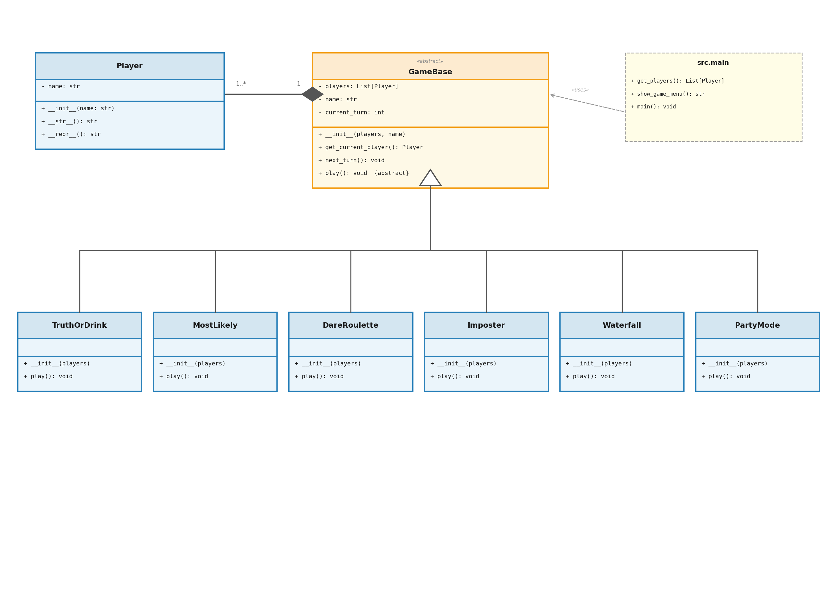
Figure 2: Class Diagram for Chupi

Sequence Diagrams
Sequence Diagram 1: Player Registration
The main module prompts the user for the number of players, validates that it is between 2 and 10, then iterates through each slot prompting for a name, validating it is non-empty, and creating a Player object. The completed list of Player objects is returned to the main loop.
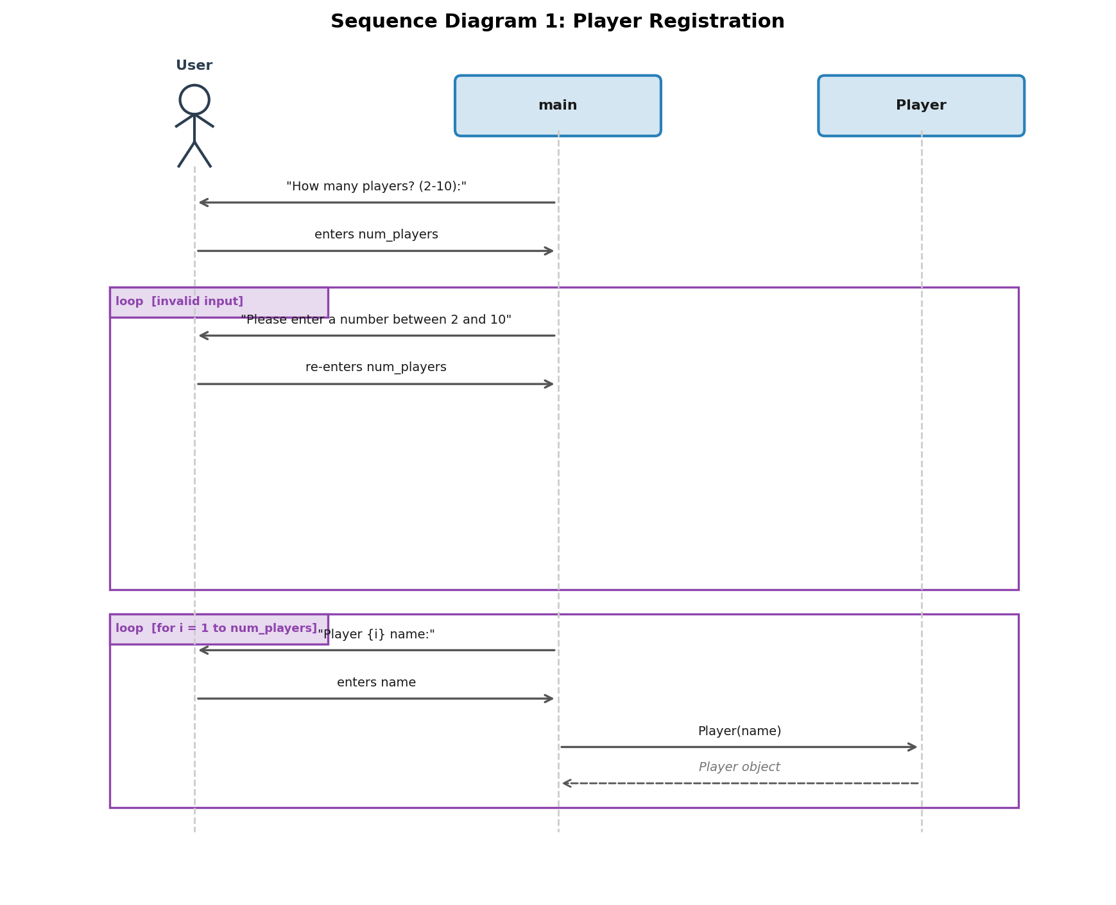
Figure 3: Sequence Diagram — Player Registration
Sequence Diagram 2: Game Selection and Launch
After registration, the main module calls show_game_menu() which displays the seven game options. The user enters a choice, which is validated. The main module looks up the corresponding game class in a dictionary, instantiates it with the player list, and calls play() on the game instance. Upon completion, the user is asked if they want to play again.
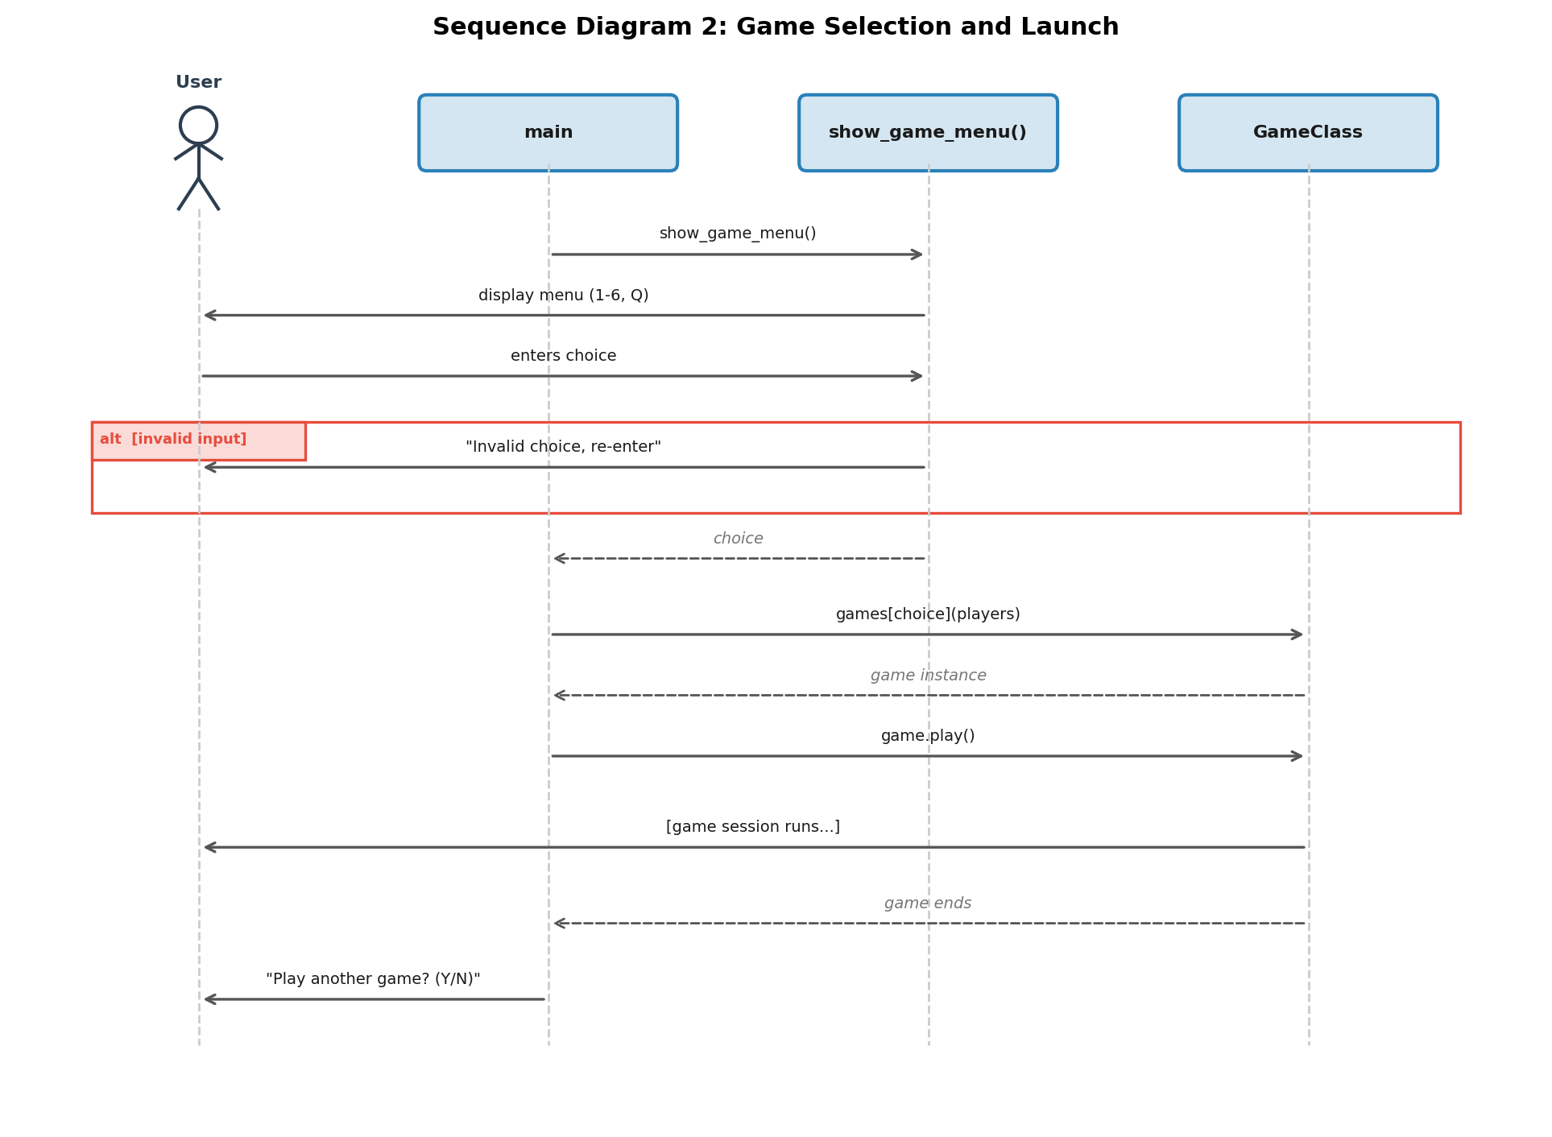
Figure 4: Sequence Diagram — Game Selection and Launch
Sequence Diagram 3: Playing a Turn-Based Game (Truth or Drink)
The TruthOrDrink instance displays the game title and rules. It then enters a loop: calling get_current_player() from GameBase to determine whose turn it is, presenting a question to that player, receiving the player’s response (answer or drink), and calling next_turn() to advance. This loop repeats until the game ends or the user exits.
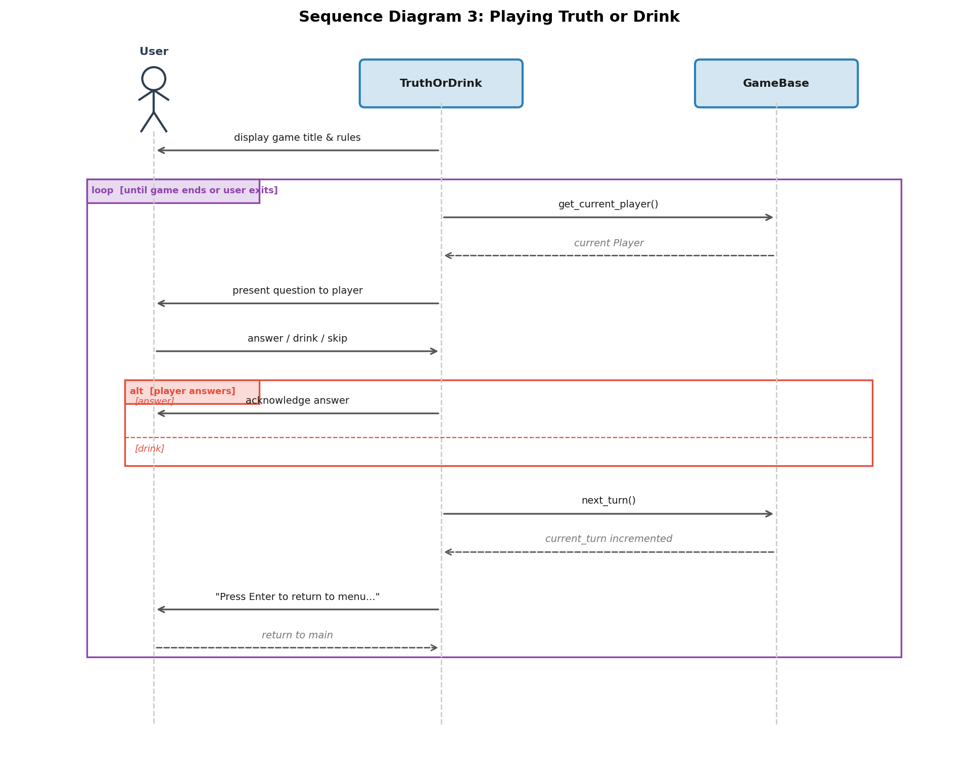
Figure 5: Sequence Diagram — Playing Truth or Drink

Operating Environment
The current console prototype runs on any system with Python 3.8 or higher installed. It has been tested on macOS, Windows 10/11, and Ubuntu Linux 22.04. The application requires only the Python standard library and has no external package dependencies for the prototype phase (the requirements.txt file is currently empty).
The planned final product will be a mobile-responsive website. The target operating environment for the web version includes modern browsers (Chrome 90+, Safari 14+, Firefox 88+, Edge 90+) on both iOS and Android devices. The web application is anticipated to use a Python-based backend framework (e.g., Flask or Django) served behind a standard web server, with HTML, CSS, and JavaScript on the frontend.
Development is performed using virtual environments (Python venv) to isolate dependencies. Git and GitHub are used for version control and collaboration.

Assumptions and Dependencies
Assumptions
All players are located in the same physical space and can share a single device screen or pass the device between turns. Players are assumed to be of legal drinking age in their jurisdiction. The application assumes a stable runtime environment where Python is properly installed and accessible from the command line. It is assumed that the number of concurrent players will not exceed 10 per session.
Dependencies
The console prototype depends on Python 3.8+ and its standard library (no third-party packages are required). The final web version will depend on a Python web framework (Flask or Django), a frontend framework or templating engine for responsive design, and a hosting platform capable of serving Python web applications. The project relies on GitHub for version control and team collaboration. Future increments may introduce dependencies on a database system for persistent data and a real-time communication library (e.g., WebSockets) for multiplayer synchronization.

